Assignment 3 CIND 719 Chantal Sylvestre

Loading the data to HDFS under directory ‘/user/a3’

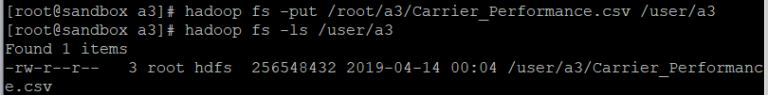

-------------------------

-- PySpark Scripts

-------------------------

**Question 1:**

**Loading and exploring the dataset:**

carrier_raw=sc.textFile("/user/a3/Carrier_Performance.csv")



carrier_raw.count()



carrier_raw.take(3)

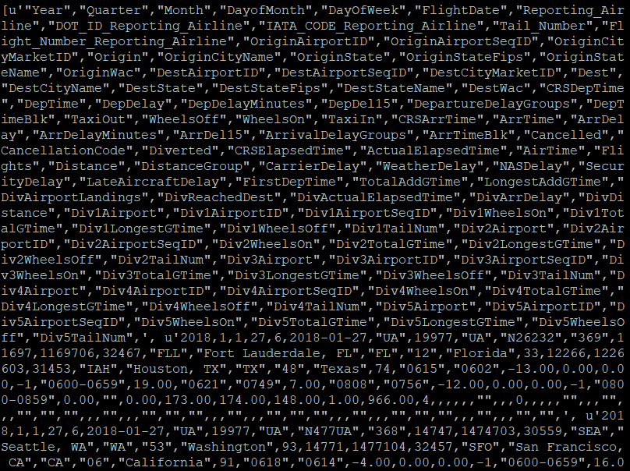

**Cleaning up the dataset, splitting by comma and removing double quotes and the header line:**

carrier_clean=carrier_raw.map(lambda x :x.split(','))

carrier_clean.take(3)

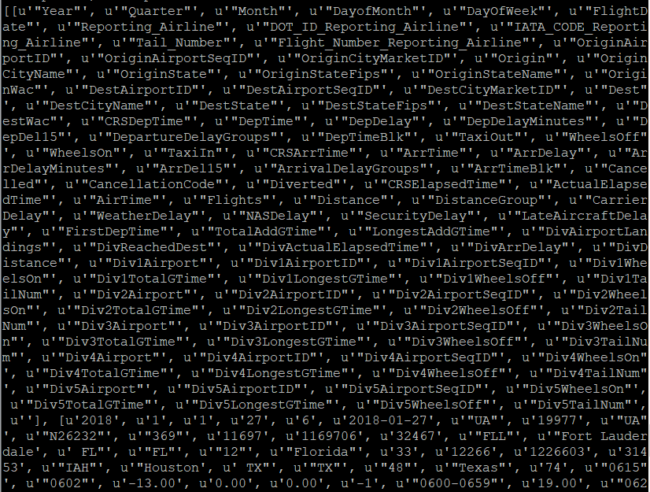

def clean(x):

return([xx.replace('"','') for xx in x])

carrier_clean=carrier_clean.map(clean)

carrier_cleanh=carrier_clean.filter(lambda x : x[0]!='Year')

carrier_cleanh.count()



carrier_cleanh.take(3)

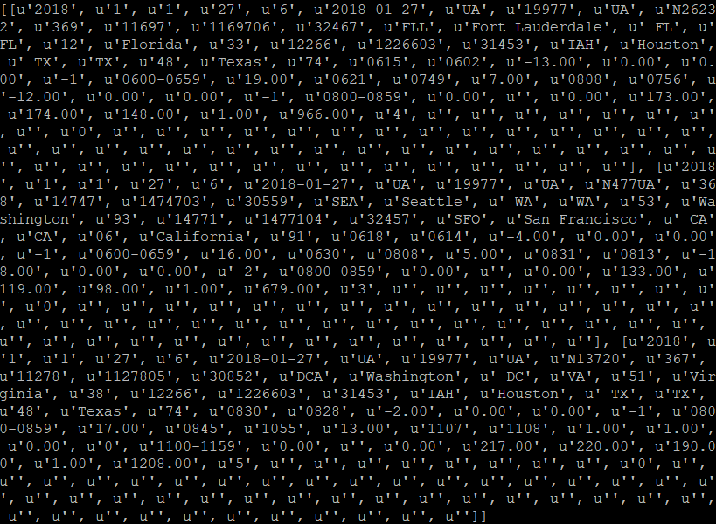

**Creating the taxi in RDD, removing 0s and creating float for time field:**

carrier_taxi_in=carrier_cleanh.map(lambda x :(x[48], x[41]))

carrier_taxi_in.take(3)



carrier_taxi_inc=carrier_taxi_in.filter(lambda x : x[1]!='')

carrier_taxi_inc.count()



carrier_taxi_inc=carrier_taxi_inc.map(lambda fields :(fields[0], float(fields[1] )))

carrier_taxi_inc.take(3)



carrier_taxi_inc=carrier_taxi_inc.reduceByKey(lambda a, b:b+a)

carrier_taxi_inc.collect()

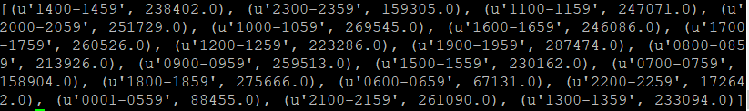

**Creating the taxi out RDD, removing 0s and creating float for time field:**

carrier_taxi_out=carrier_cleanh.map(lambda x :(x[37], x[38]))

carrier_taxi_out.take(3)



carrier_taxi_outc=carrier_taxi_out.filter(lambda x : x[1]!='')

carrier_taxi_outc.count()



carrier_taxi_outc=carrier_taxi_outc.map(lambda fields :(fields[0], float(fields[1])))

carrier_taxi_outc.take(3)



carrier_taxi_outc=carrier_taxi_outc.reduceByKey(lambda a, b:b+a)

carrier_taxi_outc.collect()

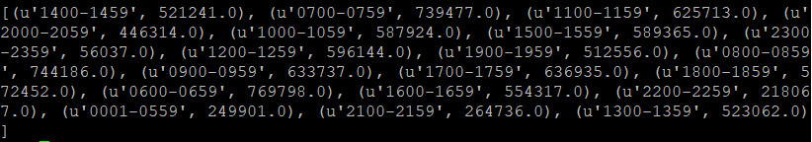

**Joining the two RDDs:**

carrier_taxi_outc.join(carrier_taxi_inc).sortByKey(1).collect()

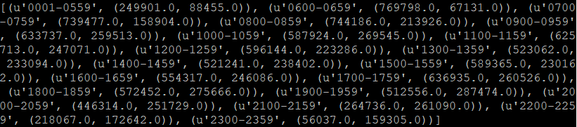

**Sorting in ascending order:**

taxi_joined =carrier_taxi_out.join(carrier_taxi_in).sortByKey(1).collect()

for elem in taxi_joined:

print elem

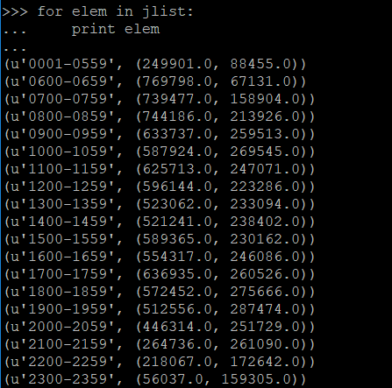

**Question 2:**

**Creating RDD of dalay times and removing 0s:**

carrier_delayraw=carrier_cleanh.map(lambda x :(x[8], x[9],x[34]))

carrier_delay=carrier_delayraw.filter(lambda x :x[2]!='0.00')

carrier_delay.count()



carrier_delay.take(3)



carrier_delay=carrier_delay.filter(lambda x :x[2]!='')

carrier_delay.count()



carrier_delay.take(3)



carrier_delayf=carrier_delay.map(lambda x :((x[0]+x[1]) ,float(x[2])))

carrier_delayf.take(3)



**Reducing by key value pairs by V:**

carrier_delayf=carrier_delayf.reduceByKey(lambda a, b:b+a)

carrier_delayf.sortBy(lambda x:x[1], ascending = False).take(25)

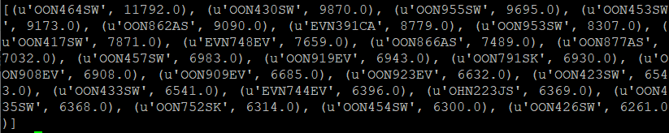

**Sorting and taking first 25 lines:**

delay_list = carrier_delayf.sortBy(lambda x:x[1], ascending = False).take(25)

for elem in delay_list:

print elem

